**CSC3060 AIDA – Assignment 3**

##### Dewei Liu

##### 40216004

##### Monday, 16 December 2019

# Contents

Contents 2

Introduction 3

Section 1 4

Question 1.1 4

Objective 4

Reasoning 4

Implementation 4

Result 4

Question 1.2 6

Question 1.3 7

Question 1.4 8

Question 1.5 9

Section 2 10

Section 2.1 10

Section 3 11

Section 3.1 11

Conclusions 12

References 13

# Introduction

In this document, please replace [StudentNumber], [FNAME], etc, with the appropriate values. The FirstNme and LastName on the report should match your first name and lastname as it appears on QOL and QSIS.

Lorem ipsum dolor sit amet, consectetur adipiscing elit, sed do eiusmod tempor incididunt ut labore et dolore magna aliqua. Ut enim ad minim veniam, quis nostrud exercitation ullamco laboris nisi ut aliquip ex ea commodo consequat. Duis aute irure dolor in reprehenderit in voluptate velit esse cillum dolore eu fugiat nulla pariatur. Excepteur sint occaecat cupidatat non proident, sunt in culpa qui officia deserunt mollit anim id est laborum.

# Section 1

## Question 1.1

### Objective

The objective of this question is to differentiate living and non-living things using the feature verticalness.

### Assumption

The critical p-value is set as

### Reasoning

Logistic Regression (LR) will be used as a method in the analysis. LR uses the Sigmoid function (Equation 1), and as a result, it produces values between 0 and 1 (Chandrayan, 2019).

Equation 1 Logistic Regression (Devereux, 2019)

Since the objects are needed to be classifies into two classes, we can set a cut-off value. If the LR model produces a value which is greater than the cut-off value, the object will be identified as a class. Otherwise, it will be identified as the opposite class.

### Implementation

The data frame with two columns verticalness and living is constructed. The values in the column living are Boolean values indicating if the observation is a living thing.

The data then is fit into the LR models. By interpreting the result of the trained model, we can decide if the feature verticalness is a sufficient feature to differentiate living and non-living things.

### Result

The summary of the data fitted into the model is as Table 1.

verticalness living

Min. :0.07534 Min. :0.0

1st Qu.:0.36631 1st Qu.:0.0

Median :0.50616 Median :0.5

Mean :0.51907 Mean :0.5

3rd Qu.:0.61048 3rd Qu.:1.0

Max. :1.27027 Max. :1.0

Table Summary of verticalness ~ logistic living value data

After fitting the model, the result of the model is as Table 1.

Call:

glm(formula = living ~ verticalness, family = "binomial", data = data)

Deviance Residuals:

Min 1Q Median 3Q Max

-1.23105 -1.16944 0.00095 1.17767 1.19216

Coefficients:

Estimate Std. Error z value Pr(>|z|)

(Intercept) -0.08656 0.37516 -0.231 0.818

verticalness 0.16676 0.65547 0.254 0.799

(Dispersion parameter for binomial family taken to be 1)

Null deviance: 221.81 on 159 degrees of freedom

Residual deviance: 221.74 on 158 degrees of freedom

AIC: 225.74

Number of Fisher Scoring iterations: 3

Table Result of Linear Regression Model

For the Intercept value in the table, the estimate is , which means the model predicts the value of living is given the verticalness value is 0. The z-score is , which is calculated as . It shows the estimate is standard error away from 0. According to the z-score and the degrees of freedom value, p-value of this variable is calculated to be which is larger than the critical p-value. We consider rejecting the hypothesis that intercept value is differ from 0.

For the verticalness value in the table, the estimate is , which means if the verticalness value increases by 1 unit, the predicted value of living will be increased by 0.16676 unit. The z-score is , which is calculated as . It shows the estimate is standard error away from 0. According to the z-score and the degrees of freedom value, p-value of this variable is calculated to be which is larger than the critical p-value. We reject the hypothesis that the value of living is correlated to the verticalness value.

According to the result of the model, the coefficient of the estimates of the intercept and verticalness is and , respectively, which derives the Equation 2 and Figure 1.

Equation 2 LR Model

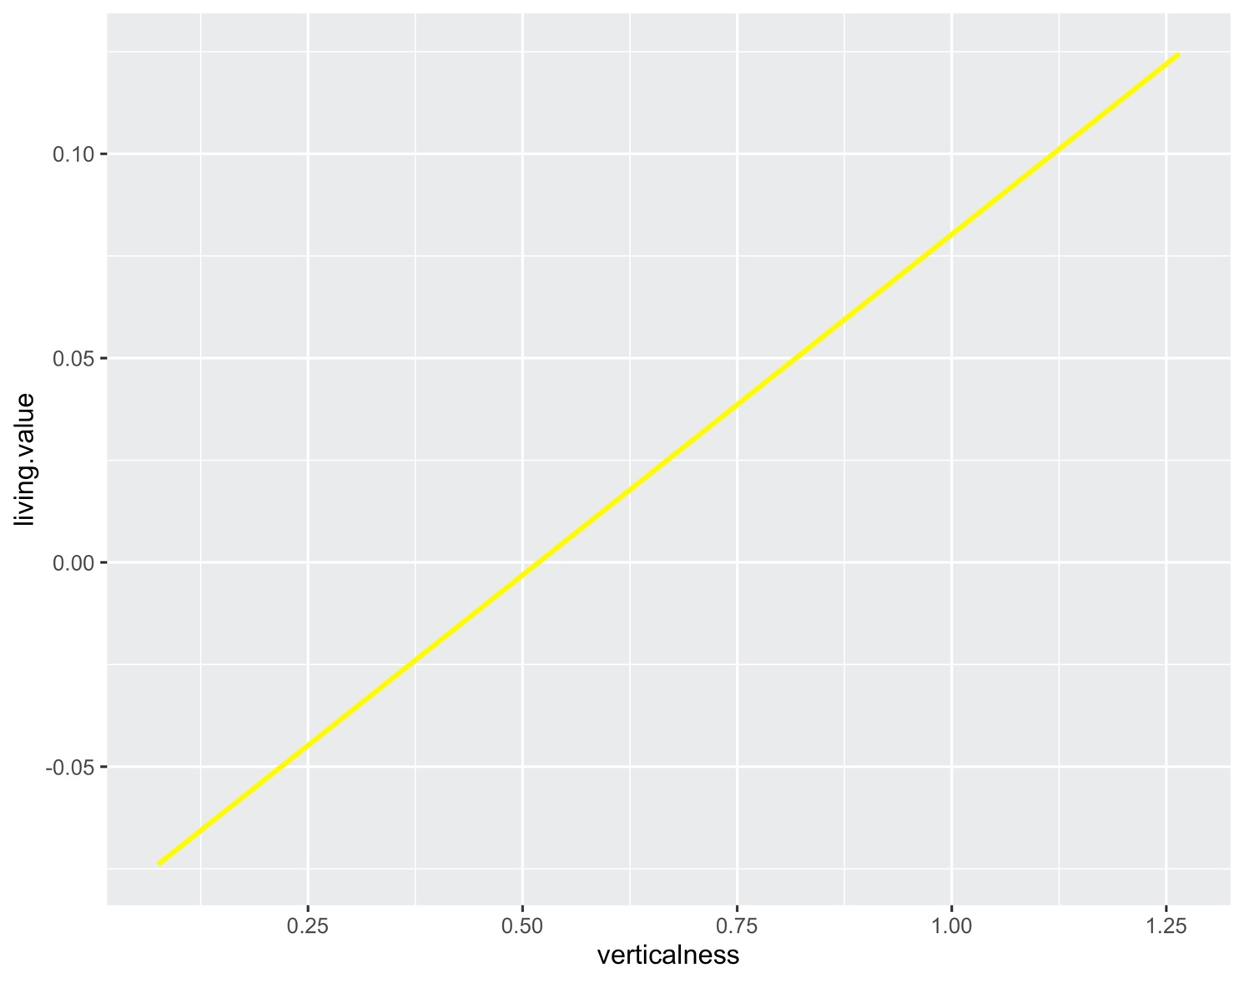

Figure 1 Regression Line living.value ~ verticalness value

## Question 1.2

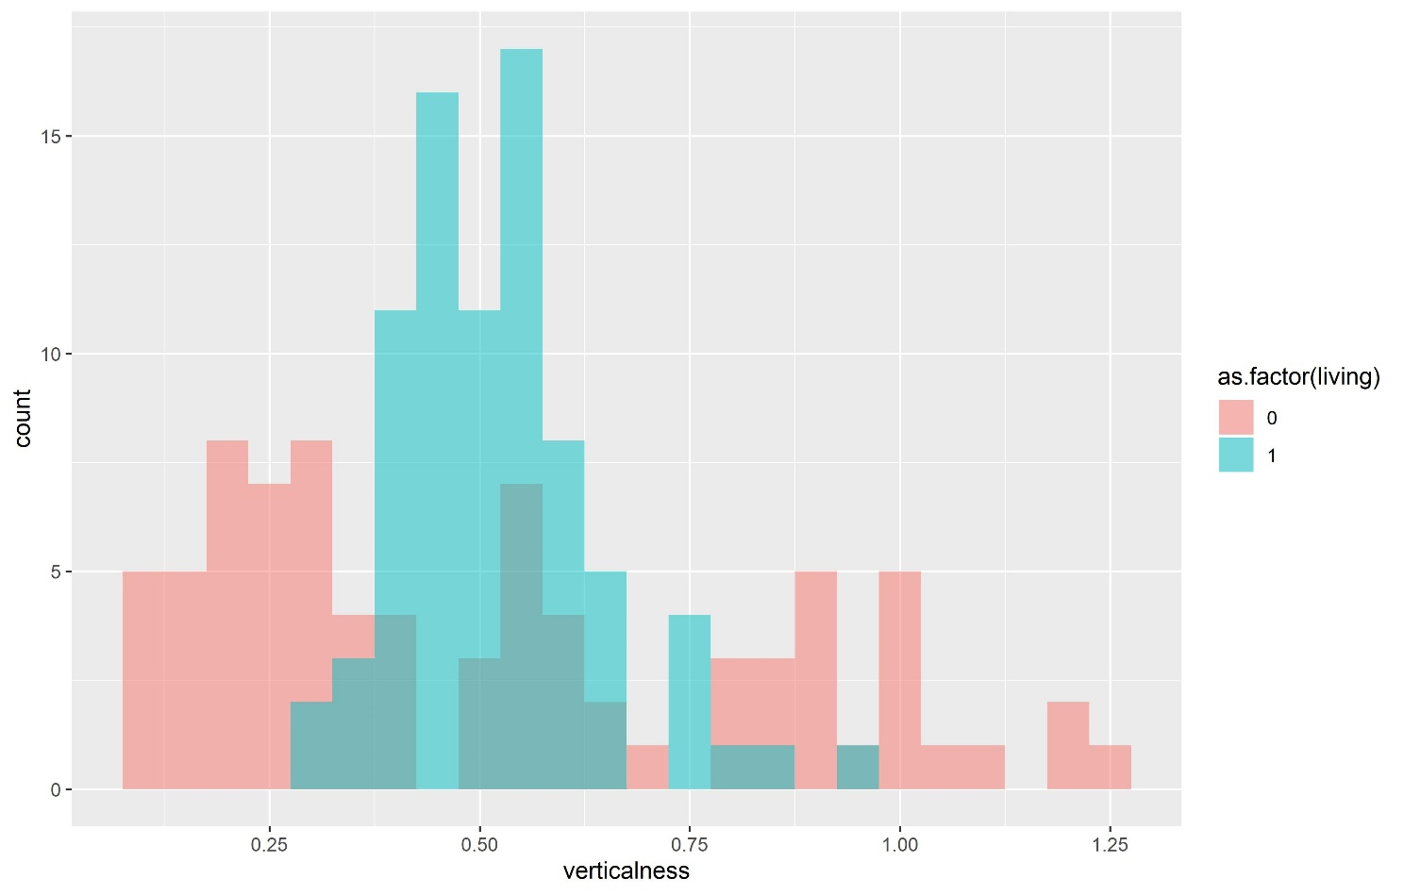

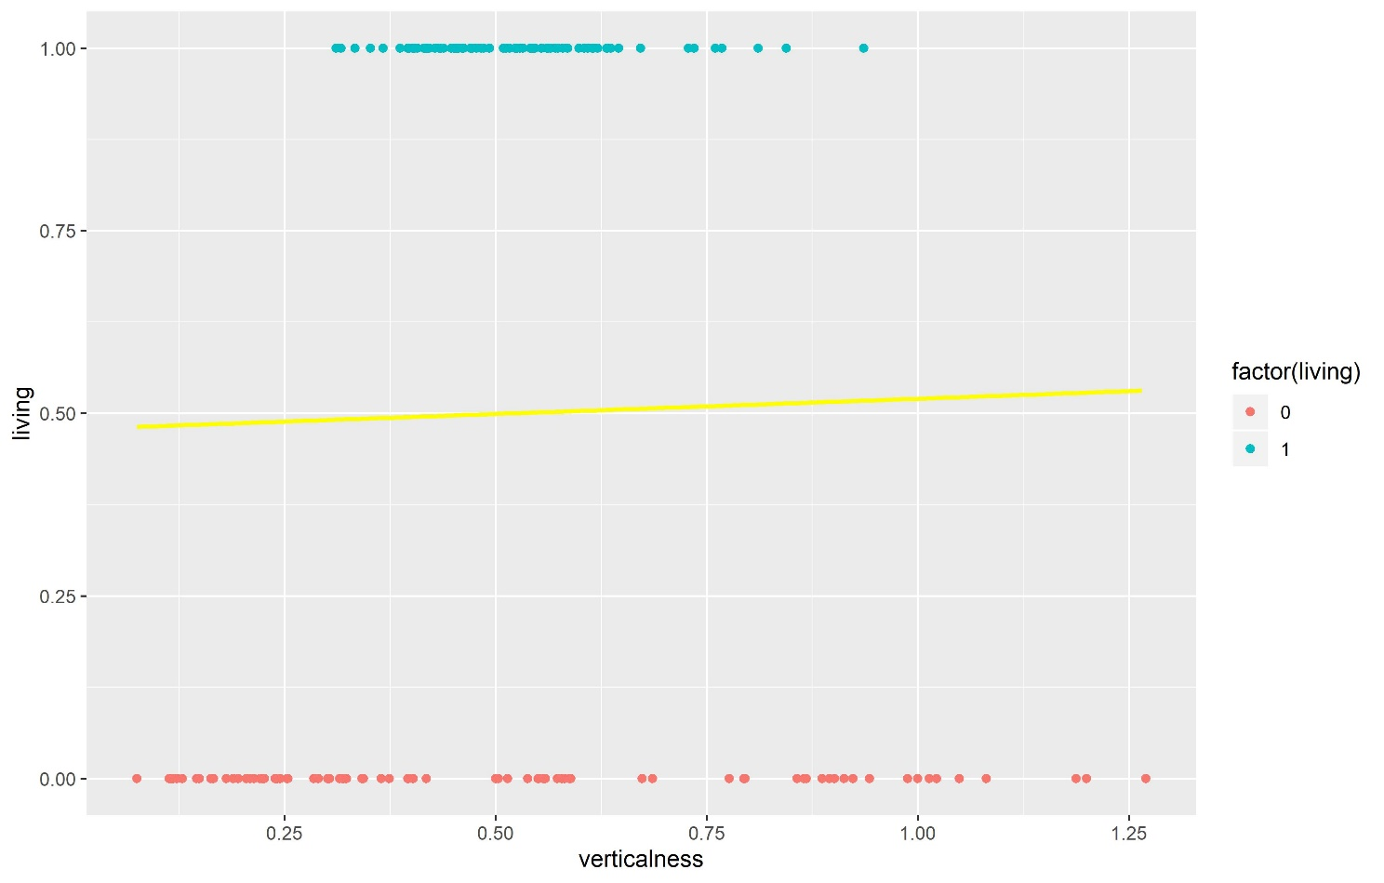

## Question 1.3

## Question 1.4

## Question 1.5

# Section 2

Lorem ipsum dolor sit amet, consectetur adipiscing elit, sed do eiusmod tempor incididunt ut labore et dolore magna aliqua. Ut enim ad minim veniam, quis nostrud exercitation ullamco laboris nisi ut aliquip ex ea commodo consequat. Duis aute irure dolor in reprehenderit in voluptate velit esse cillum dolore eu fugiat nulla pariatur. Excepteur sint occaecat cupidatat non proident, sunt in culpa qui officia deserunt mollit anim id est laborum.

## Section 2.1

Lorem ipsum dolor sit amet, consectetur adipiscing elit, sed do eiusmod tempor incididunt ut labore et dolore magna aliqua. Ut enim ad minim veniam, quis nostrud exercitation ullamco laboris nisi ut aliquip ex ea commodo consequat. Duis aute irure dolor in reprehenderit in voluptate velit esse cillum dolore eu fugiat nulla pariatur. Excepteur sint occaecat cupidatat non proident, sunt in culpa qui officia deserunt mollit anim id est laborum

# Section 3

Lorem ipsum dolor sit amet, consectetur adipiscing elit, sed do eiusmod tempor incididunt ut labore et dolore magna aliqua. Ut enim ad minim veniam, quis nostrud exercitation ullamco laboris nisi ut aliquip ex ea commodo consequat. Duis aute irure dolor in reprehenderit in voluptate velit esse cillum dolore eu fugiat nulla pariatur. Excepteur sint occaecat cupidatat non proident, sunt in culpa qui officia deserunt mollit anim id est laborum.

## Section 3.1

Lorem ipsum dolor sit amet, consectetur adipiscing elit, sed do eiusmod tempor incididunt ut labore et dolore magna aliqua. Ut enim ad minim veniam, quis nostrud exercitation ullamco laboris nisi ut aliquip ex ea commodo consequat. Duis aute irure dolor in reprehenderit in voluptate velit esse cillum dolore eu fugiat nulla pariatur. Excepteur sint occaecat cupidatat non proident, sunt in culpa qui officia deserunt mollit anim id est labour

# Conclusions

Lorem ipsum dolor sit amet, consectetur adipiscing elit, sed do eiusmod tempor incididunt ut labore et dolore magna aliqua. Ut enim ad minim veniam, quis nostrud exercitation ullamco laboris nisi ut aliquip ex ea commodo consequat. Duis aute irure dolor in reprehenderit in voluptate velit esse cillum dolore eu fugiat nulla pariatur. Excepteur sint occaecat cupidatat non proident, sunt in culpa qui officia deserunt mollit anim id est laborum.

# References

Chandrayan, P. (2019, August 15). *Logistic Regression For Dummies: A Detailed Explanation* . Retrieved from Towardsdatascience: https://towardsdatascience.com/logistic-regression-for-dummies-a-detailed-explanation-9597f76edf46

Devereux, B. (2019, December 16). *160 Topic 16 - Intro to Machine Learning.pptx .* Retrieved from Canvas: https://canvas.qub.ac.uk/courses/8433/files/487509?module_item_id=205271